FEB 2026 version

ID: _

Joint-Directed Immunomodulatory Low-Dose Radiation Prescription for Arthritis
BEAM | PALMAR (Field 1) | DORSAL (Field 2)
Site | HAND
Laterality | LEFT
Verified Rx in Sensus EMR
Cumulative dose per course | 3 Gy/course (300 cGy/course) prescribed to midplane
Dose per FRACTION | 0.50 Gy/fx | ( 50 cGy/fx) prescribed to midplane
Cumulative dose per Beam | 1.5 Gy per beam | 1.5 Gy per beam
Beam Waiting | 50% | 50%
Dose per fraction per beam | 0.25 Gy per fraction per beam | 0.25 Gy per fraction per beam
Time (minutes)
Total Fraction no. | 6 fractions | 6 fractions
SSD w/in applicator | 10 cm applicator - 25 cm SSD | 10 cm applicator - 25 cm SSD
SSD lid | Lead - 1 cm SSD | Lead - 1 cm SSD
SSD (cm) within box
Caliper Measurement
Total SSD (cm) | _cm (box) + _cm (lid) + _ cm (applicator) =_ cm | _cm (box) + _cm (lid) + _ cm (applicator) =_ cm
Energy | 100 kV  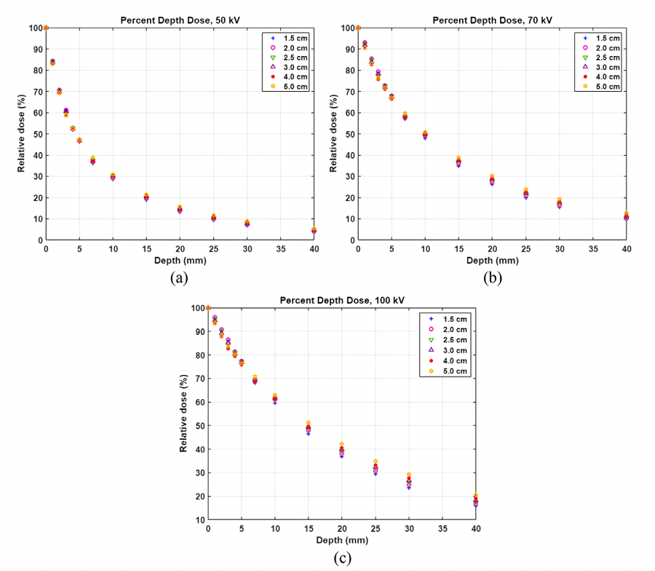 | 100 kV  
Extended SSD  Reference Data | 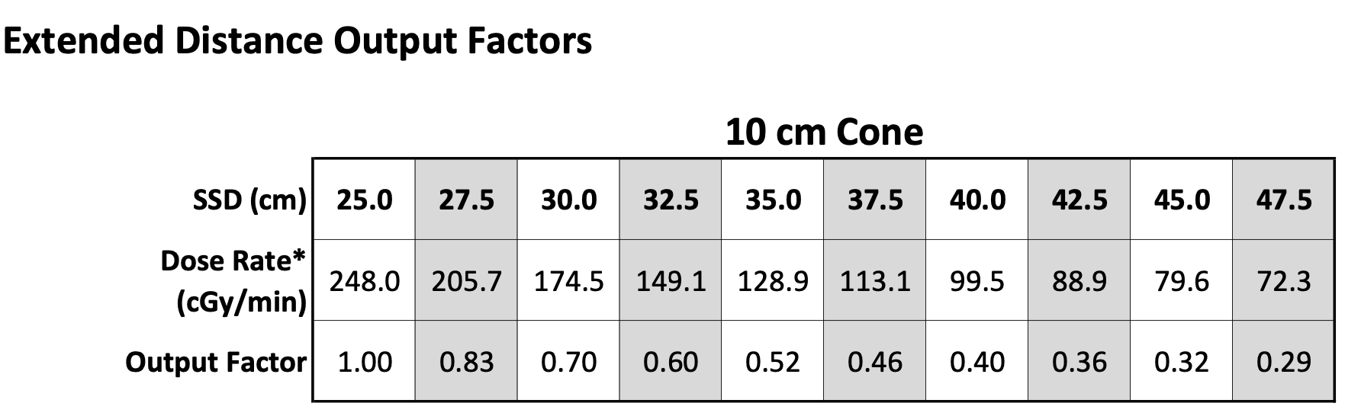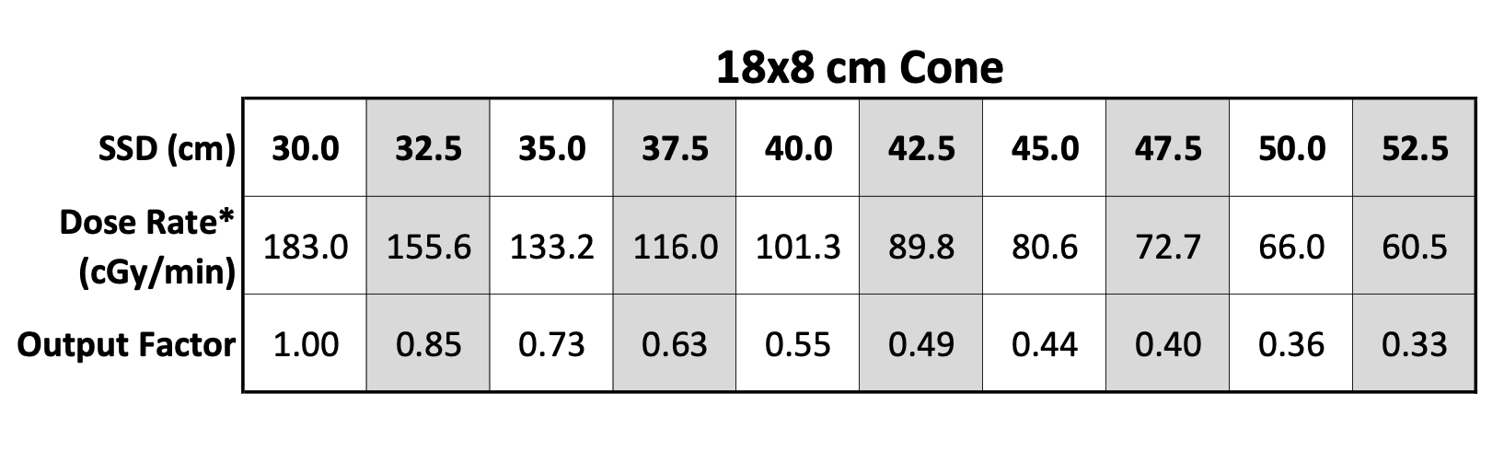
Corrected Dose Calculation
Applicator size | 10.0 cm | 10.0 cm
Margin | mm around lesion | mm around lesion
Technique | Superficial XRT | Superficial XRT
Lead Shield #1 Size
Lead Shield #2 Size
Lead Shield #3 Size
Thyroid Shield | YES | YES
Lead Apron | YES | YES
Nasal Bullet | None | None
Eye Shield Interior | None | None
Eye Shield Exterior | None | None
Lead Glasses | YES | YES
Dose Rate | per plan | per plan
Beam Arrangement | En Face Kilovoltage Photons | En Face Kilovoltage Photons
Technique | Depth-Enabled Epidermal Sparing Superficial XRT | Depth-Enabled Epidermal Sparing Superficial XRT
Beam Weighing | % | %
Fractions per day | 1 | 1
Fractions per week | 2 or 3 | 2or 3
Single or Multi phase/beam | Single Phase  Multibeam | Single Phase  Multibeam
Synchronous vs Sequential | Sequential | Sequential
Plan Type | 2DCRT - Clinical Setup | 2DCRT - Clinical Setup
Beam Arrangement | APPA
Imaging (77387) | Daily X-ray: 100 kV w/ filter and treatment shield in place (for image guidance) | Daily X-ray: 100 kV w/ filter and treatment shield in place (for image guidance)
Image-guidance Code | 77387 X-ray Guidance | 77387 X-ray Guidance
Alignment | Align field visually  Confirm radiographically | Align field visually  Confirm radiographically
In Vivo Dosimetry/Film  (77331) | YES | YES
**GRID | NO | NO
**Concurrent Therapy | NO | NO
**Pre-Authorized | NA | NA
SIM ORDER Drawn Target on RADIOGRAPH

(Sim order photos with margins drawn by RadOnc)

Sim Image: Inked Target
Sim Image: Side nozzle view
Boxtop:
Beam’s Eye View
SSD photographs

Image-Guidance DICOM
Radiograph as seen in PACS

Electronically Signed by: | Clayton B. Hess, MD, MPH  Radiation Oncologist
Date Ordered: | Mar 31, 2026

- Basic Dosimetry Calculation (CPT 77300) is billed for each specific dose calculation, such as monitor units or point doses to verify radiation delivery for [e.g., target volume across 3 overlapping orthovoltage beams]. These calculations are critical to account for dose fall-off at extended SSDs and beam overlap for deeper tissue penetration.
- Simple Teletherapy Isodose Plan (CPT 77306) is charged for a basic isodose plan targeting a single treatment area with [e.g., 2 coplanar orthovoltage beams at extended SSD], using X-ray or CT data to optimize dose for [e.g., localized deep lesion]. This code applies when orthovoltage planning involves minimal beam modification for depth dosing.
- Complex Teletherapy Isodose Plan (CPT 77307) is used for advanced planning of multiple treatment areas or complex beam arrangements, such as [e.g., 4+ overlapping orthovoltage beams with wedges or blocks or grids] to enhance dose at depth while protecting [e.g., adjacent organs]. This code is justified for orthovoltage setups requiring intricate dose-volume calculations due to extended SSDs and beam convergence.
- Special Dosimetry, In Vivo (CPT 77331) is billed for in vivo measurements, such as [e.g., TLD, film, or diode readings during treatment], performed to confirm delivered dose, ensuring accuracy given the complexity of orthovoltage beam overlap at extended SSDs.
- Special Teletherapy Port Plan (CPT 77321) is reserved for specialized planning of particle therapy, hemibody irradiation, or total body irradiation (e.g., for leukemia TBI or proton therapy) and does not apply to orthovoltage treatments with extended SSDs.
- Instead, Special Treatment Procedure (CPT 77470) is charged for orthovoltage treatments planned with multiple overlapping beams at extended SSDs to treat deeper-than-skin conditions. This code captures the significant additional effort by physicians and physicists to design custom beam arrangements and perform extended SSD calculations, ensuring adequate dose delivery to subcutaneous targets while managing beam divergence and tissue sparing. It is also applicable when delivering concurrent systemic therapy for multi-modality toxicity management. All procedures were reviewed by me, with plans and calculations developed in collaboration with dosimetry and physics teams, aligning with CMS guidelines and the patient’s treatment goals.
- Scope of Prescription Document and Separate Billing: This prescription document seeks to justify charges for CPT 77300, 77306, and/or 77307 only, as these codes pertain to dosimetry and isodose planning necessary for the prescribed orthovoltage treatment. All other codes listed in LCD L34652 (CPT 77261, 77262, 77263 (Clinical Treatment Planning note), 77332, 77333, 77334,(Treatment Device Construction Note), 77336 (Weekly Physics Chart Check Note), 77427 (Treatment Management/On-Treatment Visit (OTV) Note), 77431 (Special Physics Consultation Note), 77470 (Special Treatment Procedure) are not billed on the same date as CPT 77401 and are documented in separate notes for services performed on different days.

